

Shipment Exception Application

Design Document

|  |  |  |  |  |  |  |  |
| --- | --- | --- | --- | --- | --- | --- | --- |
| **Owner** | **:** | GPI IT Digital Operations & Middleware | | | | | |
| **Revision Number** | **:** | 34 | | | | | |
|  |  |  | |  |  | | |
| **Business Users** | **:** | Customer Service, Food Services | | : | Welch, Erin | | |
| Supply Chain, Food Services | | : | McKamy, Randy | | |
| Mills | | : | Rowe, Teena; Miller, Cindy | | |
|  |  |  |  | | |  |  |
| **Created By** | **:** |  | **Modified By** | | | **:** |  |
| **Date of Original** | **:** |  | **Last Saved** | | | **:** |  |
| **Reviewers** | **:** | Voehringer, Sharon & Metalia, Julie | | | | | |
| **Developer** | **:** | Sahu, Jagdish & Nandury, Suryanarayana | | | | | |

Contents

Executive Summary 3

Business 3

Technical Stack 3

Azure & Other Components 3

Source Code Repository 3

Technical Architecture 4

User Interface 5

Functional Scenarios 6

CPB Shipment Exceptions 6

Hot Order Shipment 6

# Executive Summary

GPI has a SharePoint site (inherited from IP) that was being used to streamline processing and ease data input by creating a data interface to extract real-time transactional data from SAP. With the nearing retirement of SharePoint 2010, the application needs to be moved to a new platform. It has been decided to re-engineer the existing application using Microsoft .NET Core (3.1) web API and Angular 9. A separate Azure SQL database will be maintained for this application which also features the notifications.

## Business

The primary use of the application is to intercept the orders and shipments. The owner of the application is GPI IT Digital Operations & Middleware. Other users of the application include Account Executives, Replenishment planners, Supply Planners, Mill PS&D and management across all functions.

## Technical Stack

* Microsoft .NET Core (3.1) web API
* Entity Framework Core
* Angular 9
* Bootstrap 4.5.x with Font-Awesome Icons Package.

## Azure & Other Components

* Idaptive (for authentication)
* Azure Blob Storage
* Azure Load Balancer
* Docker
* Azure Kubernetes Service
* Azure SQL
* Redis Cache
* Azure Function
* Twillo Send Grid

## Source Code Repository

<https://github.com/graphicpkg/ShipmentExceptions.git>

# Technical Architecture

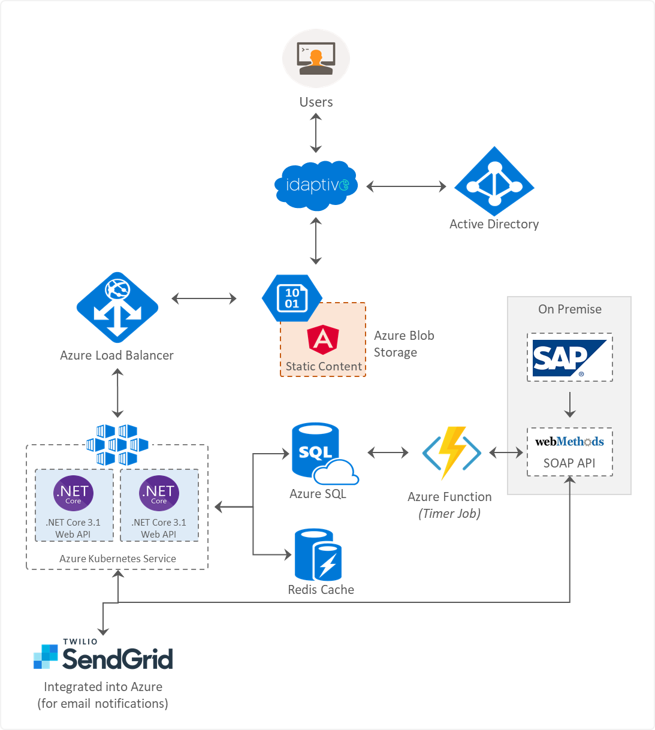

# User Interface

User interface to be created using Bootstrap 4.5.x with Font-Awesome icons package.

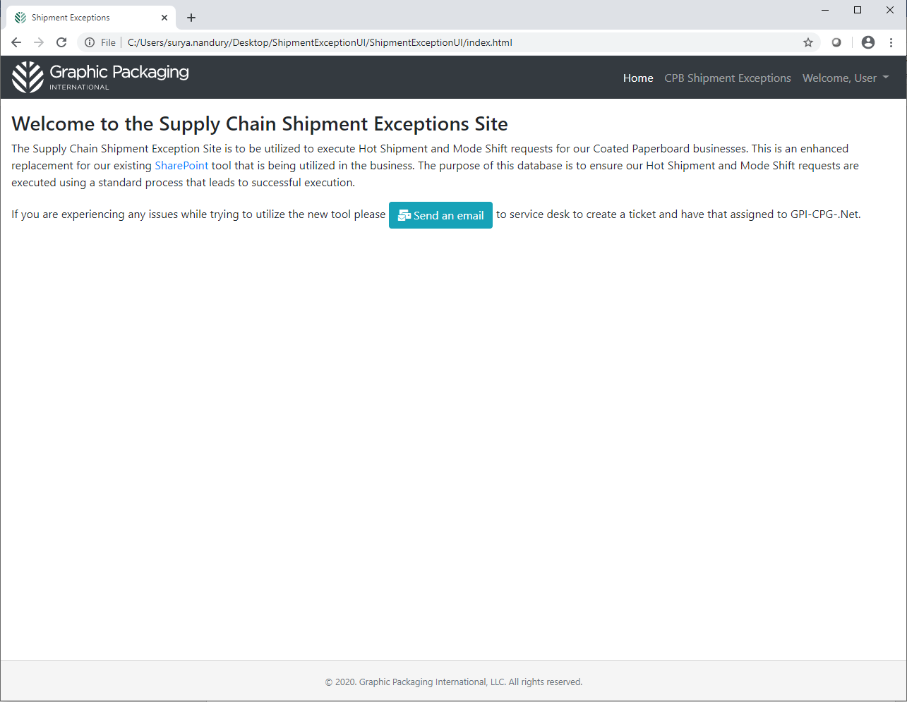

# Functional Scenarios

## CPB Shipment Exceptions

This page should show a list of all the Order details entered. This list should be exportable (to an excel). The page also has button to create a new exception which can be two types (listed below)

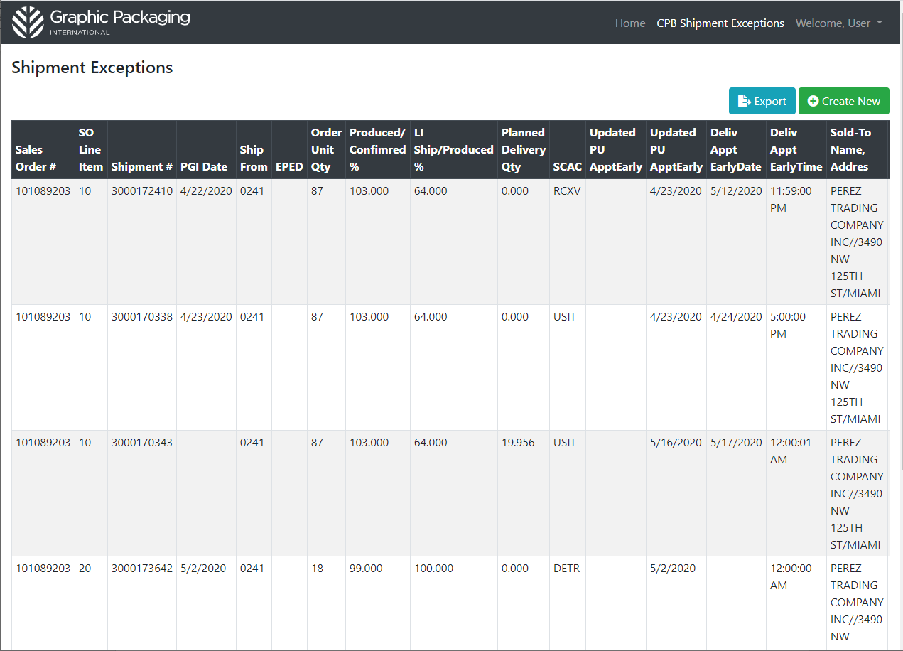

Below is the list of fields that will be shown on the grid.

* Sales Order #
* SO Line Item
* Shipment No.
* PGI Date
* Ship From
* EPED
* Order Unit Qty
* Produced/Confirmed %
* LI Ship/Produced %
* Planned Delivery Qty
* SCAC
* Updated PU ApptEarly
* Deliv Appt EarlyDate
* Deliv Appt EarlyTime
* Sold-To Name, Addres
* Account Executive
* Cust. PO
* Order Type
* Ship-To Name, Addres
* MAD
* CDD
* Delivery Window
* Container ID
* STO
* STO shipment number

This application primarily categorizes searches under two scenarios

1. Hot Order Shipment
2. Hot Mode Shift

These are two radio buttons and scenarios are explained below.

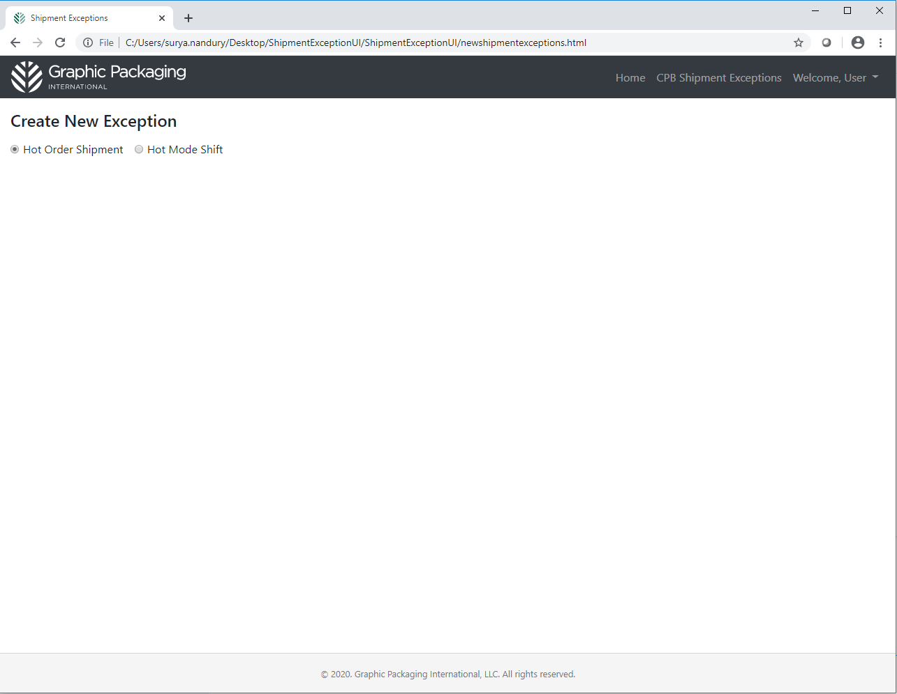

## Hot Order Shipment

When the user selected hot order shipment, the screen presents itself with an option to enter the below listed parameters.

* Sales order #
* Line item #
* Desired Delivery date and time
* Afterhours/weekend receiver name
* Phone number
* Exception reason (drop down)
* Number of loads required
* HOT order requires rolls to be transferred from another order (Check box)
  + If checked, below fields are required
    - Other sales order#
    - Other sales order line item #
* Requestor comments
* Additional People to Copy on Request Creation and Completion
* Additional People to Copy on All Workflow Steps

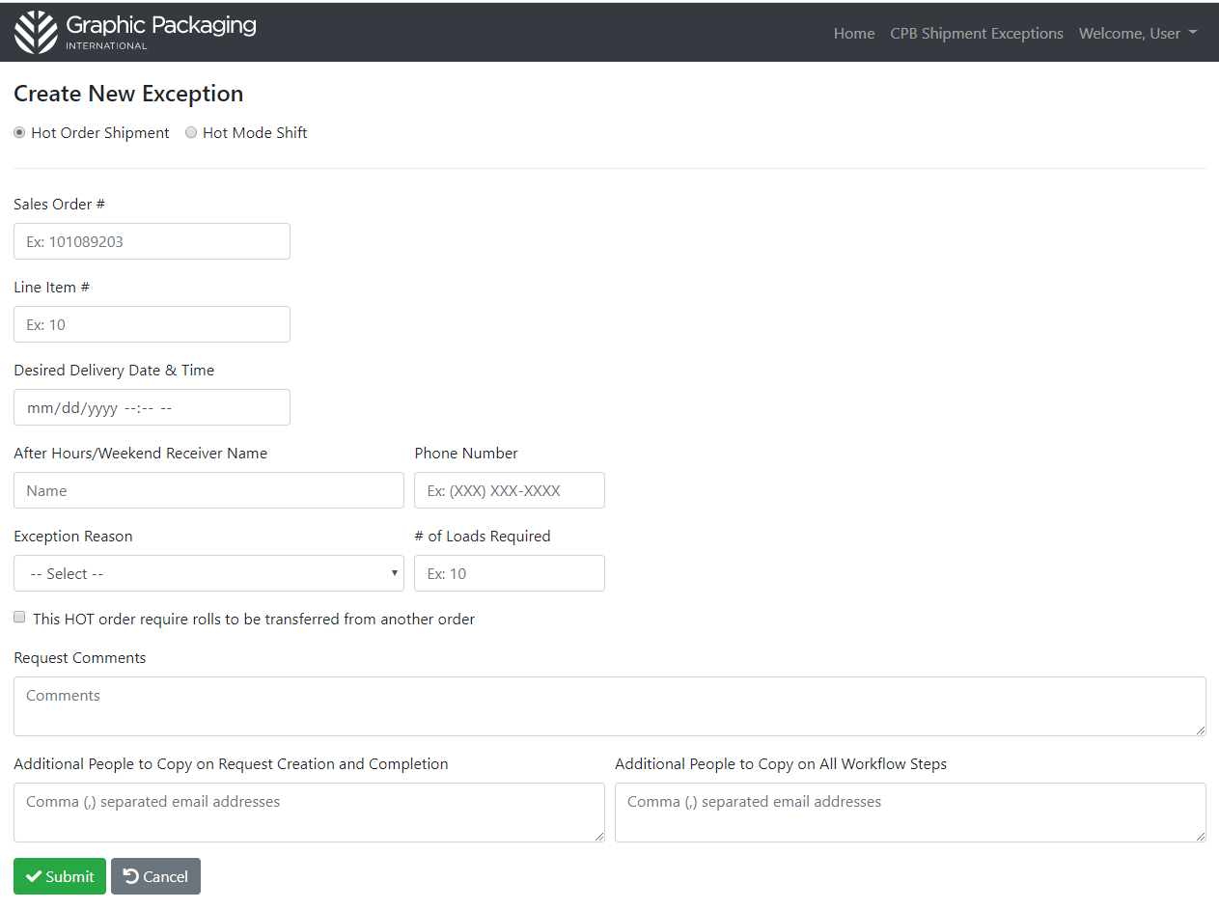

Once the user clicks on Submit, this information is submitted to a BAPI (new BAPI name) which retrieves that data from SAP (details to be added once Chetna provides them) and saved to the database.

# Workflow

## Process 1: Submit Actions

Whenever the record is saved to the database, if the SOLI is unplanned (meaning, there is no shipment retrieved) then an email is sent email to Logistics Planning team.

Once Logistics planning team completes the shipment creation process, they will go into the application and indicate such on the HOT ORDER entry and SAVE. SAVE should automatically trigger a workflow notification to the Mill Logistics Execution Team.

If the SOLI has a shipment planned, then the email goes directly to the Mill Logistics Execution Team.

## Process 2: Timer Job

This job runs every x hours (frequency yet to be decided) to evaluate all OPEN entries. Email notification to be sent to Mill logistics execution team listing all open SOLI’s with delivery appt is null AND Dely Appt Date is greater than Desired Delivery Date.

There will also be a nightly job to review all entries in the application. If all shipments associated with a SOLI entry have a shipment end date (PGI) then mark the entry as closed.